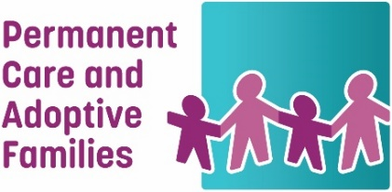
Permanent Care and Adoptive Families Inc.
P O Box 201, Fitzroy 3065
T: 9020 1833 E: info@pcafamilies.org.au
W: www.pcafamilies.org.au
ABN 50 562 164 576
Rapid Antigen Test (RAT) distribution form
PCA Families have been provided RAT tests from DFFH to distribute to permanent care families and others receiving the DFFH care allowance for their young people aged 3-17, for free. Each young person is eligible for 1 test per week. Currently you can apply for 4 tests for each child.
Please email this form to info@pcafamilies.org.au requesting the required number of boxes of RAT tests (five tests/box).
Name:
Address:
Email
Phone:
Number of children:
Number of boxes (number of children x 4)/5 tests:
Melbourne collection
Please note the collection date and time will be agreed once your form has been received. Please select which collection point is suitable.

- Collect from FCAV
Ground Floor, 2 Greenwood St, Abbotsford

- Collect from PCA Families
247-251 Flinders Lane, Melbourne

- Tested positive to COVID-19 and need RATs to be posted home

Please circle or highlight the days of week you are available to collect RATs

Monday Tuesday Wednesday Thursday Friday (by appointment only)

Regional distribution
Depending on demand, we may be able to post to your address, but will contact you for further information on how to best distribute to you.

