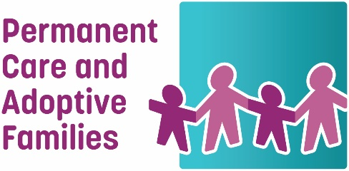
Permanent Care and Adoptive Families Inc.
Suite 6, 69-71 Rosstown Rd, Carnegie 3163
T 03 9020 1833 E info@pcafamilies.org.au
W www.pcafamilies.org.au
ABN 50 562 164 576

Nomination Form for Board Directors to be elected at 2023 Annual General Meeting

Name of Nominee:
Address:
Tel No:
Email:

Position Nominating For
Please select one option:

☐ Option 1:
My personal and family connection to Permanent Care and Adoption is:

________________________________________________________________________________________

☐ Option 2:
I do not have close personal or family connection to Permanent Care or Adoption but am interested because:

_______________________________________________________________________________________

Biographical Statement for Nomination
Please provide a short biographical statement to support your nomination to the PCA Families Board.

* The Board has defined “A close personal or family connection to permanent care or adoption” as an individual who has either:
(a) Direct lived experience currently or previously as a permanent carer, adoptive parent, child/young person under a Permanent Care Order or adopted child (“lived experience child/young person”); or

(b) Close family connection currently or previously to an individual with direct lived experience as:

Partner/spouse of a permanent carer/adopted parent or a lived experience child/young person, - children/young people or other dependents living in household with lived experience child/young person for more than 12 months (e.g., foster/kinship care children, parents of carers/parents).

For the purposes of this definition, permanent care and adoption include the following:
(a) Permanent care statutory order
(b) Local or intercountry adoption orders
(c) Interstate equivalents to permanent care or adoption orders (e.g., long term guardianship orders)
(d) Long term informal kinship care of a child/young person who cannot live with their birth parents.

Nominations must be endorsed by a PCAF member other than the nominee.

Nominated by:
Tel No:
Email:
Signature

I confirm:

- I consent for my name and details to be provided for nomination to the PCAF Board.
- I am not disqualified from managing a corporation under the Corporations Act, nor form being a responsible entity under the Australian Charities and Not-for-profit Commission Act.

Signed:
Date:

Please return to: chair@pcafamilies.org.au or chris@pcafamilies.org.au
by 5.00 p.m. on Friday 15th September 2023

Please note that this nomination will be invalid
unless this form has been fully completed.

